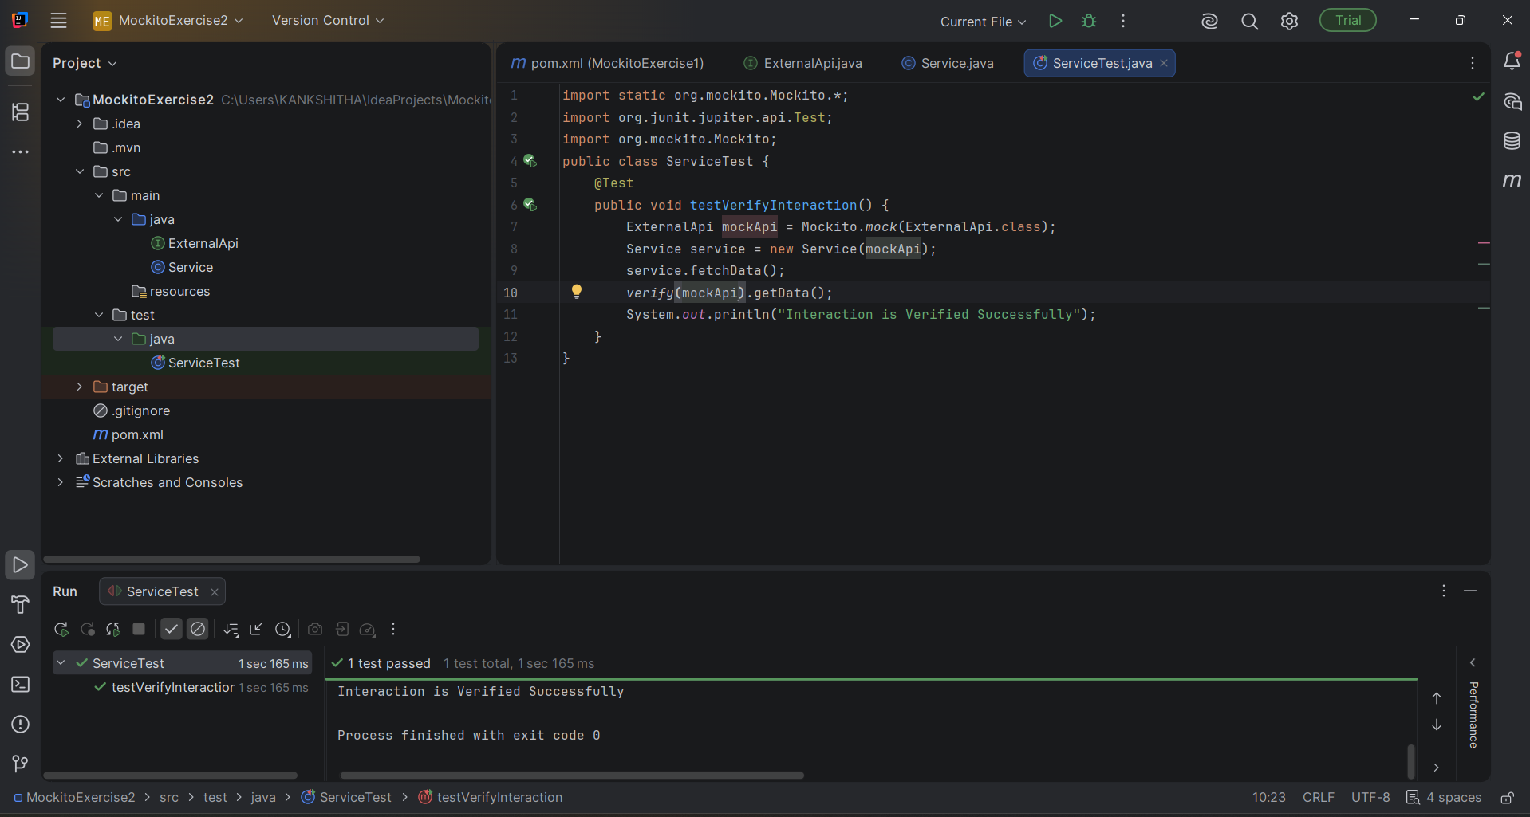
Output:

The test case has been passed and the output is obtained that,
“Interaction is verified successfully.”

